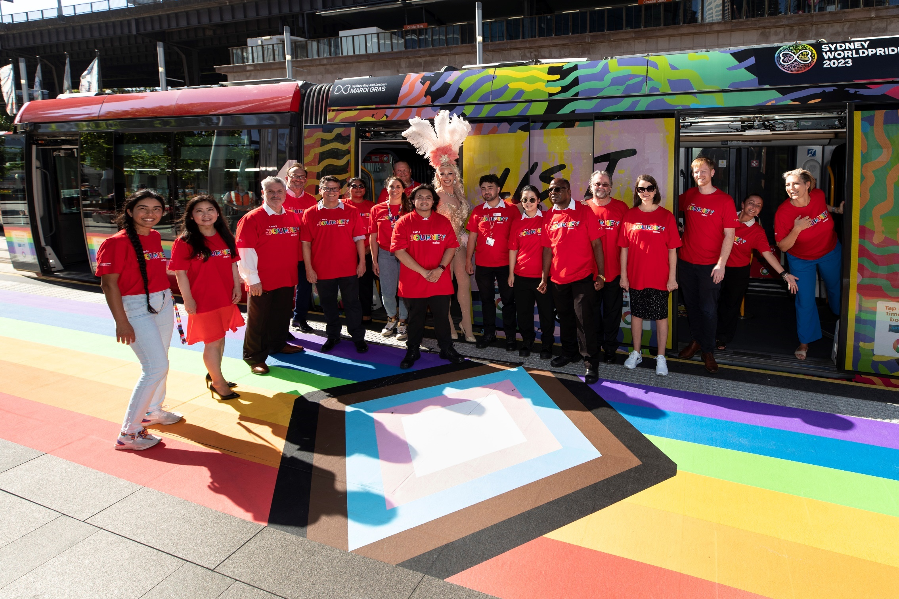

Accessibility & Inclusion Action Plan

November 2024 - November 2026

Contents
Acknowledgment of Country 3
Our Purpose 3
Our operations in Australia and New Zealand 4
A message from our leadership team 5
Brian Brennan 5
Huw Bridges 6
Partnerships & Accreditations 8
Our Commitments & Key Focus Areas 11
Key events in the DEI calendar 18
Regulatory Framework 19
Contact 20

Acknowledgment of Country
Transdev acknowledges the Traditional Owners of the land on which we meet, work, and learn. We pay our deepest respects to the First Nations Peoples and their Elders past, present and emerging.

Our Purpose
Transdev is at the heart of keeping our communities moving. We provide public transport services in seven locations in Australia and New Zealand. Globally, we enable 11 million trips daily across five continents and 18 countries.
We empower freedom to move everyday thanks to safe, reliable, and innovative solutions that serve the common good.
We pride ourselves on leading the way in public transport through the collaboration of our teams and a shared commitment to delivering excellence in all that we do.
In Australia and New Zealand, we specialise in the operations and maintenance of numerous passenger transport modes, including heavy and light rail, ferries, buses, and coaches. Globally, we operate and maintain a range of transport modes including metro, paratransit, cable car and bus rapid transit.
We define ourselves as The Mobility Company. We are people moving people.

Our operations in Australia and New Zealand

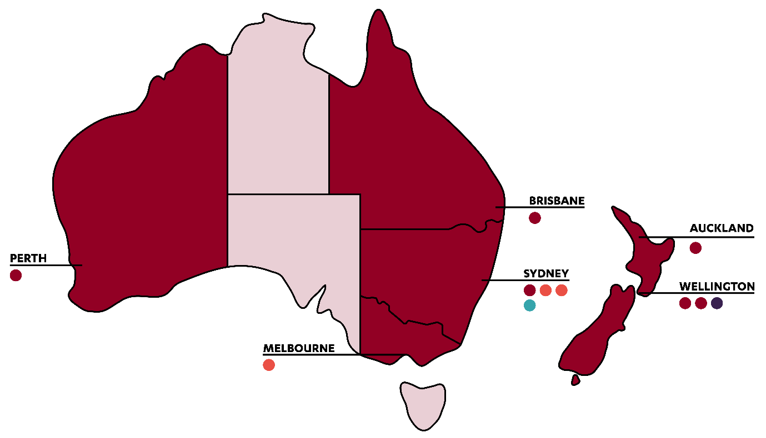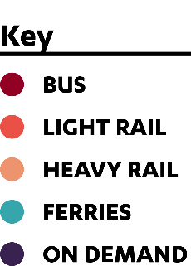

A message from our leadership team

Brian Brennan
Chief Executive Officer of Transdev Australia and New Zealand
At Transdev, we believe that Diversity, Equity, and Inclusion belongs at the core of our business.
With around 1 in 5 Australians living with disability, an increasingly ageing population and 9.1% of Australians speaking a language other than English at home, it is important that we design our products, vehicles, services and employment pathways with accessibility and inclusion in mind.
Our 2024-2026 Accessibility and Inclusion Action Plan (AIAP) outlines our commitment to make our services more inclusive and accessible for everyone in our community. It will also ensure that our workplace and recruitment practices are more inclusive and accessible for current and future Journey Makers.
At Transdev, we believe that true inclusion will only be achieved through ensuring equity, opportunity, and respect for all, across the organisation. I am therefore extremely proud of us as an organisation for advancing our commitments to accessibility and inclusion, and for actively striving to support better outcomes and pathways that promote positive economic and social change for all.

Brian Brennan
Chief Executive Officer, Transdev Australia & New Zealand

Huw Bridges
Chief Safety & Assurance Officer, Transdev Australia & New Zealand
As one of the leading providers of transport operations across Australia and New Zealand, Transdev has a duty of care to ensure all our customers arrive at their destination safely. Our mission is to ensure safe, reliable, and innovative public transportation services for everyone in the communities we serve. We aim to create environments and services where people feel supported, included, and are committed to ensuring our workplace is fully accessible and inclusive for our Journey Makers, customers and clients.
Transdev Australia and New Zealand’s 2024-2026 Accessibility and Inclusion Action Plan has been developed to support our commitment to accessibility and inclusion. It embeds accountability across all our transport modes and business functions in Australia and New Zealand. Along with our 2024-2026 Innovate Reconciliation Action Plan and 2024-2026 Gender Equality Action Plan, this Plan is a subset of Transdev’s Diversity, Equity, and Inclusion (DEI) Strategy.
I am proud to be the Executive Sponsor of our Inclusion pillar at Transdev. Diversity is an organisational strength, and this compels us to take tangible actions which ensure everyone feels safe when they travel, partner or work with us.
This Plan outlines Transdev’s commitments to growing and maturing our DEI partnerships, stretching our accreditation aspirations, embracing inclusive hiring practices and creating a workplace where people feel comfortable in bringing their whole selves to work.
By delivering on this Plan’s priorities under a robust governance framework, we’ll create opportunities and drive an inclusive capable culture of shared social responsibility while attracting, developing and empowering current and future Journey Makers.
I’m excited about the positive changes the Accessibility and Inclusion Action Plan will catalyse in our organisation over the next few years. I welcome your feedback and help, so we can continue to collaborate and make inroads on this critical issue across our Australia and New Zealand operations.


Huw Bridges
Chief Safety & Assurance Officer, Transdev Australia & New Zealand

Partnerships & Accreditations
Our existing partnerships and proactive memberships have influenced Transdev’s Diversity, Equity and Inclusion Strategy and enabled us to embrace best practice inclusion initiatives.
In 2023, we were proud to be recognised as an Australian Workplace Equality Index (AWEI) Bronze Tier employer by Pride in Diversity. AWEI is the definitive national benchmark on LGBTQ+ workplace inclusion and is the largest - and only - national employee index designed to gauge the overall impact of inclusion initiatives on organisational culture.
Furthermore, in 2021 Transdev was recognized as a Certified Customer Service Organisation by the Customer Service Institute of Australia. This recognition was based on our achievements in meeting the International Customer Service Standard (ICSS: 2020-2025) and for ongoing delivery of our customer service excellence strategy.
Transdev is also a Bronze Member of the Australian Disability Network, the peak body for disability inclusion in the workplace. Australian Disability Network is a national, membership-based, for-purpose organisation that helps businesses welcome and retain people with disability in all aspects of business.
We also take pride in our ability to strengthen national and local ties with community organisations and leaders in inclusion who partner with us to diversify our supply chain, create more equitable employment pathways and celebrate success on our accessibility and inclusion journey. These organisations include:
Diversity Council Australia is Australia’s lead body for diversity and inclusion research, information, news, events and learning.
Job Access was created by the Australian Government as a national hub for workplace and employment information for employers of people with disability to ‘drive disability employment’.
Australian Partners of Defence enable us to promote our employment opportunities to serving Australian Defence Force personnel, reservists, allied forces, veterans and their immediate families.
Asuria partner with us to create inclusive and innovative employment pathways for candidates from diverse social and professional identities including young people, people returning to work, people with disability, First Nations Peoples and people from culturally and linguistically diverse (CALD) backgrounds.
Social Traders are assisting us to generate impactful and sustainable social enterprise procurement outcomes.
The Veteran Employment Program (VEP) improves support for veterans as they more from the ADF to civilian employment. We are proud to have signed the Veteran Employment Commitment and be recognised as a VEP partner.

“I’m excited to see Transdev’s accessibility and inclusion journey mature over the term of their Plan and looking forward to supporting them achieve their ambitious goal to achieve Advanced AWEI accreditation in 2026, creating a safer and more inclusive workplace for members of the LGBTQ+ community.”
Zachary Lopez
Pride in Diversity Relationship Manager



Our Commitments & Key Focus Areas
Transdev is committed to improving access and inclusion for current and future Journey Makers and the communities we serve. Our efforts are aligned with the Transdev Group Strategy. This strategy focuses on six key arenas which we use to help drive our initiatives.
Our Accessibility and Inclusion Action Plan takes the six arenas and integrates them with some of the key areas of focus from Australian Disability Network’s Access and Inclusion Index. Taken together, these initiatives guide the development of our priorities and actions which delivers a structured and comprehensive approach to accessibility and inclusion.
We are committed to reviewing all actions to advance our inclusion progress annually, at minimum, over the term of this Plan. Our long-term approach is designed to extend beyond the term, ensuring sustained progress – and meaningful action – in all aspects of accessibility and inclusion.

Priority
Commitment to best practice
Actions
Elevate our existing Bronze Australian Workplace Equality Index accreditation to Silver in 2026.
Utilise Australian Disability Network’s tools to annually self-reflect on our access and inclusion progress and to align our future efforts with industry best practice.
Undertake an annual self-assessment to understand how well we are currently performing in terms of accessibility, diversity and inclusion.
Strive to advance our 2020 Customer Service Excellence score, via assessment by the Customer Service Institute of Australia and certification to the International Customer Service Standard (ICSS).
Deliver DEI e-learning to all Managers and Frontline-Leaders.
Deliver DEI Toolbox Training to frontline workers.

Priority
Premises
Actions
Grow and support employee resource networks aligned to this Plan including our Pride Network.
Seek to achieve international accreditations and recognition aligned to our global efforts to be recognised as an employer of choice.
Asses all new properties to ensure they are accessible or able to be adjusted where required.
Adjust existing properties where possible and as required based on the accessibility needs of its users.

Priority
Workplace Adjustments
Actions
Develop a Policy and Procedure for employees and new starters to request Workplace Adjustments.
Ensure our Flexible Work policy is promoted and understood across our business.
Establish regular reporting for workplace adjustments requests and approvals.
Monitor the accessibility of the process and ensure users have a mechanism to provide feedback.
Ask and record preferred communication method for employees.

Priority
Communications and Marketing
Actions
Review our Accessibility and Inclusion Guidelines (AIG) and update these where required to increase accessibility and inclusion.
Audit our content to ensure compliance with our AIG.
Survey Journey Makers to gather baseline data and measure improvements relating to awareness, attitudes and perceptions toward people from diverse backgrounds.
Celebrate days of significance by meaningfully communicating and engaging with internal and external stakeholders.

Priority
Products and Services
Actions
Ensure each business unit has an Accessible Transport Action Plan in place.
Comply with the Disability Standards for Accessible Public Transport 2002.
Conduct qualitative customer research gathering exercises to analyse customer experiences and identify key priorities.

Priority
Digital Accessibility
Action
Comply, where possible, with the Web Content Accessibility Guidelines 2.1 AAA.

Priority
Recruitment and Selection
Actions
Embed Disability Confident Recruiter principles and practices, aspiring for formal status recognition.
Ask candidates as part of the application process if they require any reasonable adjustments to our hiring process to accommodate diverse needs e.g. vacancy details in alternative formats.
Review our position descriptions and ensure that the selection criteria is consistent with the inherent requirements of the role.
Educate and empower hiring managers and recruiters to aspire for effective, bias-free recruitment processes.
Review and update our recruitment tools, templates and resources to identify, and remove, any unintended barriers to employment for prospect hires and career development opportunities for existing employees.
Increase ways to collect DEI data and feedback during recruitment and onboarding to improve metrics and enable continuous improvement.
Diversify our employment pathways to attract more candidates for targeted roles e.g. for graduate programs and youth-focused initiatives.

Priority
Career Development and Mobility
Action
Review and update policies and procedures to ensure equal access to career development, leadership training and other opportunities to all employees.

Priority
Suppliers and Partners
Actions
Develop a list of preferred suppliers and partners, who demonstrate commitment to fostering DEI.
Influence the accessibility and inclusivity of organisations in our supplier network by sharing knowledge, challenges and this Plan.
Establish regular stakeholder engagement activities to promote social enterprises.
Grow our network of external partners that can assist us to deliver on our actions and diversify our workforce.

Priority
Leadership and Innovation
Actions
Establish an accountability, governance and reporting framework to measure progress against AIAP actions.
Consult publicly to inform accessibility and inclusivity of future transport.
Continue to represent Transdev externally at working groups, disability forums, community groups or information sessions related to accessible transport.
Establish quarterly AIAP reporting metrics.
Table the AIAP as an agenda item at all Executive Leadership Team meetings.

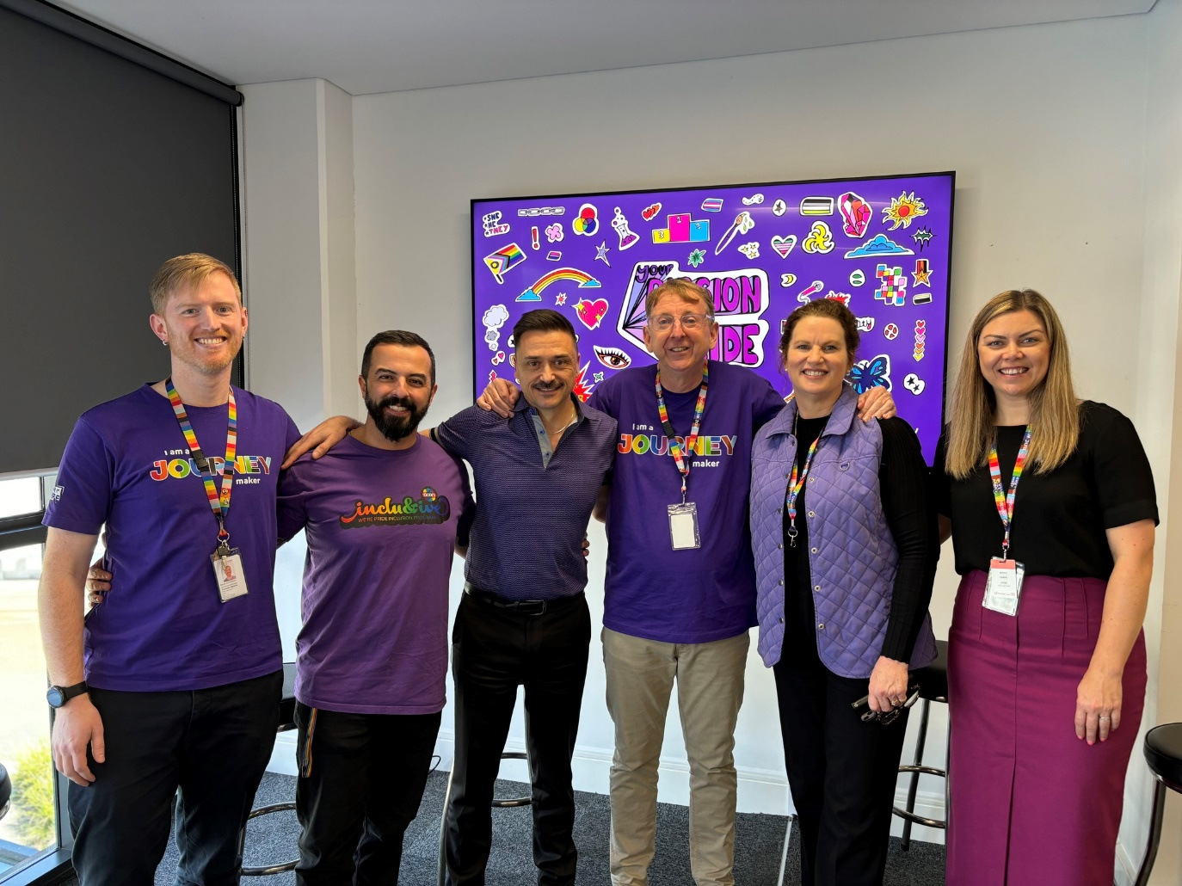
“Throughout the last 18 months Asuria has worked in partnership with Transdev to do recruitment differently. We have been grateful to Transdev for their innovative and inclusive approach to hiring our talented candidates and look forward to creating more employment pathways for candidates from diverse backgrounds with them for years to come.”
Heather Sharpe
Asuria, National Partnership Manager

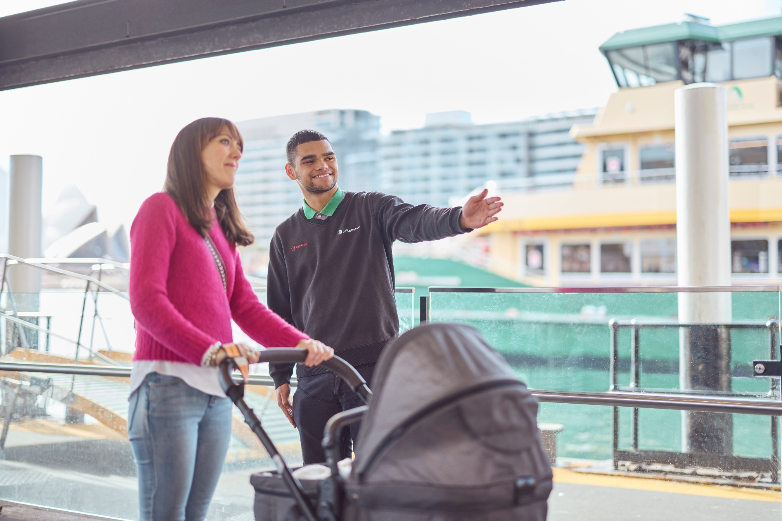

Key events in the DEI calendar
Harmony Week, March
Harmony Week is a celebration that recognises our diversity and brings together Australians from all different backgrounds. It’s about inclusiveness, respect and championing a sense of belonging for everyone. At Transdev we choose to highlight Harmony week as part of our DEI calendar to showcase the diversity across our organisation.
Wear it Purple Day, 30th August
On Wear it Purple Day, Transdev support the LGBTQ+ community, allies, friends and families. Wear It Purple strives to foster supportive, safe, empowering and inclusive environments for rainbow young people by raising awareness, providing opportunities and creating a better environment for the LGBTQ+ community.
International Day of People with Disability, 3rd December
A United Nations (UN) day observed internationally to promote community awareness, understanding and acceptance of people with disability. Each year the UN announces a theme to observe for International Day of People with Disability which Transdev promotes across our organisation.

Regulatory Framework
In the development of this Accessibility and Inclusion Action Plan, Transdev has considered and commits to abide by the relevant laws, standards and guidelines including:
Fair Work Act 2009 (Commonwealth)
Equal Opportunity Act 2010
Charter of Human Rights and Responsibilities Act 2006 (VIC)
Disability Discrimination Act 1992
Accessibility for New Zealanders Bill 2022
Human Rights Act 1993
New Zealand Bill of Rights Act 1990
Disability Standards for Accessible Public Transport 2002

Contact
Diversity, Equity, Inclusion and Talent Acquisition Manager
+61 429 560 405 | nicole.norris@transdev.com.au

Transdev Australia and New Zealand Melbourne:
Level 6, 550 Bourke St, Melbourne VIC 3000

Transdev Australia and New Zealand Sydney:
Level 19, 477 Pitt St, Haymarket NSW 2000

transdev.com.au



